**Day 5**

**CE1:**

package com.Day6;

import org.testng.annotations.Test;

import io.github.bonigarcia.wdm.WebDriverManager;

import org.testng.annotations.BeforeMethod;

import org.openqa.selenium.WebDriver;

import org.openqa.selenium.chrome.ChromeDriver;

import org.openqa.selenium.chrome.ChromeOptions;

import org.testng.Assert;

import org.testng.annotations.AfterMethod;

public class CE1 {

WebDriver d;

@Test

public void checkTitle() {

d.get("https://demo.wpeverest.com/user-registration/guest-registration-form/");

String eTitle="Guest Registration Form – User Registration";

String cTitle=d.getTitle();

Assert.assertEquals(eTitle, cTitle);

}

@BeforeMethod

public void beforeMethod() {

ChromeOptions co= new ChromeOptions();

co.addArguments("--remote-allow-origins=*");

WebDriverManager.chromedriver();

d=new ChromeDriver();

}

@AfterMethod

public void afterMethod() {

d.close();

}

}

**OUTPUT:**

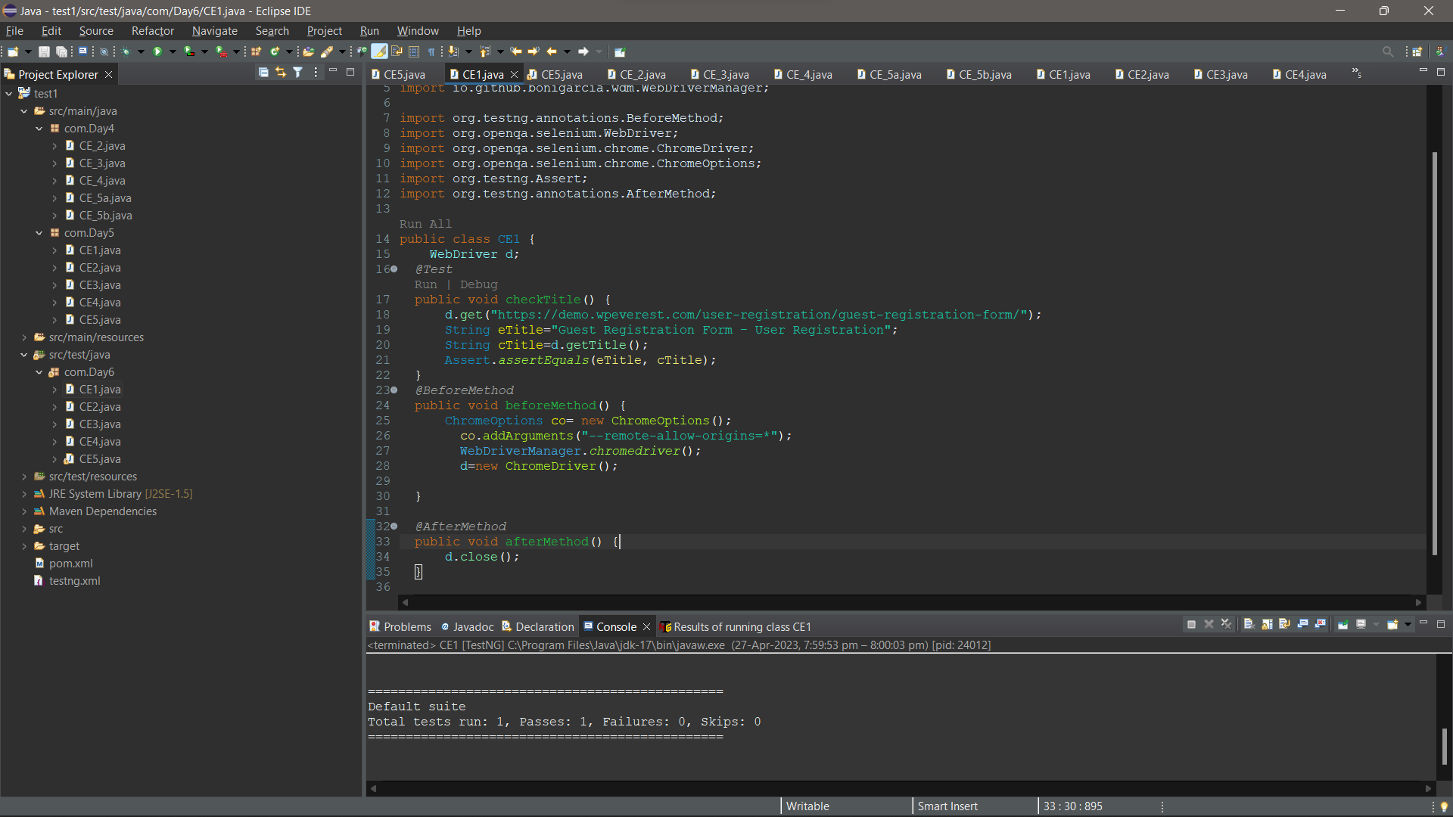

**CE2:**

package com.Day6;

import org.testng.annotations.Test;

import org.testng.annotations.BeforeMethod;

import org.testng.Assert;

import org.testng.annotations.AfterMethod;

public class CE2 {

@Test (priority=3)

public void add() {

int a=10,b=20,res=0;

res=a+b;

System.out.println("Add = "+res);

Assert.assertEquals(res, 30);

}

@Test (priority=2)

public void sub() {

int a=20,b=10,res=0;

res=a-b;

System.out.println("Sub = "+res);

Assert.assertEquals(res, 10);

}

@Test (priority=1)

public void mul() {

int a=20,b=10,res=0;

res=a*b;

System.out.println("Mul = "+res);

Assert.assertEquals(res, 200);

}

@Test (priority=4)

public void div() {

int a=20,b=10,res=0;

res=a/b;

System.out.println("Div = "+res);

Assert.assertEquals(res, 2);

}

@BeforeMethod

public void beforeMethod() {

}

@AfterMethod

public void afterMethod() {

}

}

**OUTPUT:**

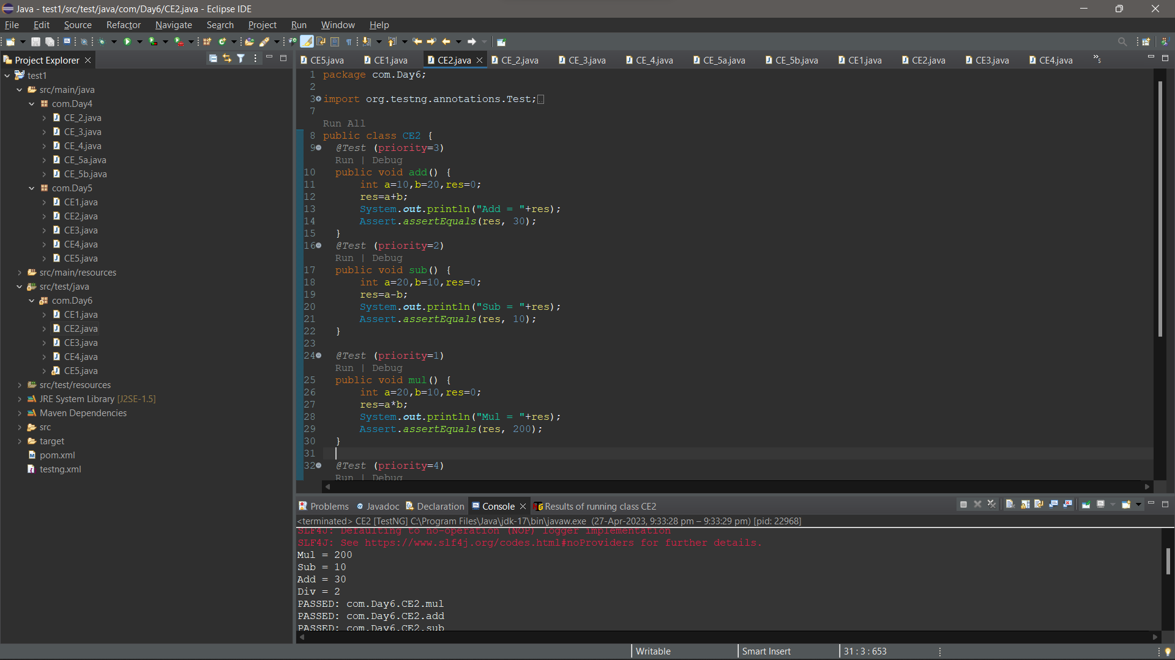

**CE3:**

package com.Day6;

import org.testng.annotations.Test;

import io.github.bonigarcia.wdm.WebDriverManager;

import org.testng.annotations.BeforeMethod;

import org.openqa.selenium.By;

import org.openqa.selenium.WebDriver;

import org.openqa.selenium.chrome.ChromeDriver;

import org.openqa.selenium.chrome.ChromeOptions;

import org.testng.Assert;

import org.testng.annotations.AfterMethod;

public class CE3 {

WebDriver d;

@Test

public void execution() throws InterruptedException {

d.findElement(By.xpath("//*[@id=\"app\"]/div[1]/div/div[1]/div/div[2]/div[2]/form/div[1]/div/div[2]/input")).sendKeys("Admin");

d.findElement(By.xpath("//*[@id=\"app\"]/div[1]/div/div[1]/div/div[2]/div[2]/form/div[2]/div/div[2]/input")).sendKeys("admin123");

Thread.sleep(3000);

d.findElement(By.xpath("//*[@id=\"app\"]/div[1]/div/div[1]/div/div[2]/div[2]/form/div[3]/button")).click();

Thread.sleep(4000);

String title = d.findElement(By.xpath("//*[@id=\"app\"]/div[1]/div[1]/header/div[1]/div[1]/span/h6")).getText();

Assert.assertEquals("Dashboard", title);

}

@BeforeMethod

public void beforeMethod() throws InterruptedException {

ChromeOptions co= new ChromeOptions();

co.addArguments("--remote-allow-origins=*");

WebDriverManager.chromedriver();

d=new ChromeDriver();

d.get("https://opensource-demo.orangehrmlive.com/web/index.php/auth/login");

d.manage().window().maximize();

Thread.sleep(4000);

}

@AfterMethod

public void afterMethod() {

d.close();

}

}

**OUTPUT:**

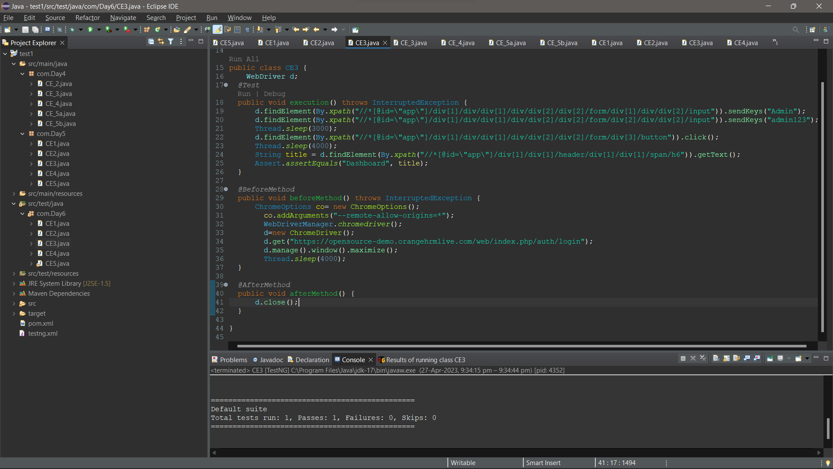

**CE4:**

package com.Day6;

import org.testng.annotations.Test;

import io.github.bonigarcia.wdm.WebDriverManager;

import org.testng.annotations.BeforeMethod;

import org.openqa.selenium.By;

import org.openqa.selenium.WebDriver;

import org.openqa.selenium.chrome.ChromeDriver;

import org.openqa.selenium.chrome.ChromeOptions;

import org.testng.Assert;

import org.testng.annotations.AfterClass;

import org.testng.annotations.AfterMethod;

import org.testng.annotations.BeforeClass;

public class CE4 {

WebDriver d;

@Test

public void login() throws InterruptedException {

d.findElement(By.xpath("//*[@id=\"app\"]/div[1]/div/div[1]/div/div[2]/div[2]/form/div[1]/div/div[2]/input")).sendKeys("Admin");

d.findElement(By.xpath("//*[@id=\"app\"]/div[1]/div/div[1]/div/div[2]/div[2]/form/div[2]/div/div[2]/input")).sendKeys("admin123");

Thread.sleep(3000);

d.findElement(By.xpath("//*[@id=\"app\"]/div[1]/div/div[1]/div/div[2]/div[2]/form/div[3]/button")).click();

Thread.sleep(4000);

String title = d.findElement(By.xpath("//*[@id=\"app\"]/div[1]/div[1]/header/div[1]/div[1]/span/h6")).getText();

Assert.assertEquals("Dashboard", title);

}

@Test(dependsOnMethods= {"login"})

public void logout() {

d.findElement(By.xpath("//*[@id=\"app\"]/div[1]/div[1]/header/div[1]/div[2]/ul/li/span/p")).click();

d.findElement(By.xpath("//*[@id=\"app\"]/div[1]/div[1]/header/div[1]/div[2]/ul/li/ul/li[4]/a")).click();

String Title=d.getTitle();

System.out.println(Title);

Assert.assertEquals("OrangeHRM", Title);

}

@BeforeClass

public void beforeclass() throws InterruptedException {

ChromeOptions co= new ChromeOptions();

co.addArguments("--remote-allow-origins=*");

WebDriverManager.chromedriver();

d=new ChromeDriver();

d.get("https://opensource-demo.orangehrmlive.com/web/index.php/auth/login");

d.manage().window().maximize();

Thread.sleep(4000);

}

@AfterClass

public void afterclass() {

}

@BeforeMethod

public void beforeMethod() throws InterruptedException {

}

@AfterMethod

public void afterMethod() {

// d.close();

}

}

**OUTPUT:**



**CE5:**

package com.Day6;

import org.testng.annotations.Test;

import io.github.bonigarcia.wdm.WebDriverManager;

import org.testng.annotations.BeforeMethod;

import org.testng.annotations.AfterMethod;

import java.util.concurrent.TimeUnit;

import org.openqa.selenium.By;

import org.openqa.selenium.WebDriver;

import org.openqa.selenium.WebElement;

import org.openqa.selenium.chrome.ChromeDriver;

import org.openqa.selenium.chrome.ChromeOptions;

import org.testng.Assert;

public class CE5 {

WebDriver d;

@Test(groups="SmokeTest")

public void testcase01() {

String title=d.getTitle();

Assert.assertEquals("Domain Names, Websites, Hosting & Online Marketing Tools - GoDaddy IN", title);

String url=d.getCurrentUrl();

Assert.assertEquals("https://www.godaddy.com/en-in", url);

}

@Test(groups="RegressionTest")

public void testcase02() {

d.manage().timeouts().implicitlyWait(5,TimeUnit.SECONDS);

d.findElement(By.xpath("//*[@id=\"id-631b049a-e9c0-4d24-8710-c504745206dd\"]/div[2]/div[1]/ul/li[1]/button")).click();

d.findElement(By.xpath("//*[@id=\"id-631b049a-e9c0-4d24-8710-c504745206dd\"]/div[2]/div[1]/ul/li[1]/div/div[2]/div[1]/ul/li[2]/a")).click();

}

@Test(groups="RegressionTest")

public void testcase03() {

d.manage().timeouts().implicitlyWait(5,TimeUnit.SECONDS);

d.findElement(By.xpath("//*[@id=\"id-631b049a-e9c0-4d24-8710-c504745206dd\"]/div[2]/div[1]/ul/li[1]/button")).click();

d.findElement(By.xpath("//*[@id=\"id-631b049a-e9c0-4d24-8710-c504745206dd\"]/div[2]/div[1]/ul/li[1]/div/div[2]/div[1]/ul/li[2]/a")).click();

String title=d.getTitle();

System.out.println(title);

d.findElement(By.xpath("//*[@id=\"8469f0c3-e08f-4343-9756-ce0390b0d581\"]")).isEnabled();

d.findElement(By.xpath("//*[@id=\"id-1467954b-c5e3-4b0c-9046-9fc94d8ca892\"]/section/div/div/section/div/div[1]/div/div/div[2]/button")).isEnabled();

WebElement input=d.findElement(By.xpath("//*[@id=\"8469f0c3-e08f-4343-9756-ce0390b0d581\"]"));

input.sendKeys("Food");

}

@BeforeMethod

public void beforeMethod() throws InterruptedException {

ChromeOptions co= new ChromeOptions();

co.addArguments("--remote-allow-origins=*");

WebDriverManager.chromedriver();

d=new ChromeDriver();

d.get("https://www.godaddy.com/");

d.manage().window().maximize();

Thread.sleep(4000);

}

@AfterMethod

public void afterMethod() {

d.close();

}

}

**OUTPUT:**

